InterviewBuddy

Software Architecture Document

Version 1.0

Revision History
Date | Version | Description | Author
30/Oct/26 | 1.0 | First complete version for PA2: goals and constraints, technology choices, use-case model, logical view with four components, data view (ERD), deployment and implementation views. | Nguyen Tran Trung Nhan

Table of Contents
1. Introduction 4
1.1 Purpose 4
1.2 Scope 4
1.3 Definitions, Acronyms and Abbreviations 4
1.4 References 4
1.5 Overview 5
2. Architectural Goals and Constraints 5
2.1 Technology Choices 6
3. Use-Case Model 6
4. Logical View 8
4.1 Component: Web Client 9
4.2 Component: API Server 10
4.3 Component: AI Integration 12
4.4 Component: Data and Authentication 13
5. Deployment 15
6. Implementation View 16

Software Architecture Document

Introduction
This Software Architecture Document (SAD) gives an architectural overview of InterviewBuddy, an AI mock-interview website for students and job seekers. It describes the significant architectural decisions of the system, the components and how they communicate, the data model, how the system is deployed and how the source code is organised.

Purpose
The document is written for the development team, so that the remaining features are built on one consistent design in Sprints 3–5, and for the instructor and teaching assistants, so that they can check that the design satisfies the requirements in the Vision Document and the Use-Case Specification.

Scope
The SAD covers the first release of InterviewBuddy: the eleven features F1–F11 of the Vision Document and the seventeen use cases of the Use-Case Specification. At the time of writing (end of Sprint 2) the following parts are implemented and running: sign-up and login (F1), CV–JD fit analysis (F2) and the interview session API used by the interview setup (F3). Components needed by later features are described as planned and marked with an asterisk (*) in the figures.

Definitions, Acronyms and Abbreviations
Term | Meaning
AI | Artificial intelligence. In this project: the Google Gemini large language model.
API | Application Programming Interface. Here: the HTTP endpoints under /api of the web application.
CV / JD | Curriculum vitae (résumé) / job description.
JWT | JSON Web Token. The access token that proves which user is signed in.
Next.js | React framework used for both the pages and the server-side API of the application.
PostgREST | The REST interface that Supabase generates for the PostgreSQL database.
Proxy | Next.js 16 name for middleware: code that runs on the server before every request.
RLS | Row Level Security. PostgreSQL rules that limit which rows each user can read or change.
Supabase | Hosted PostgreSQL database with authentication and an automatic REST API.
UC-xx / Fx | Use case number in the Use-Case Specification / feature number in the Vision Document.

References
Document | Location
Vision Document | /docs/requirements/InterviewBuddy_Vision_Document.docx
Use-Case Specification | /docs/requirements/InterviewBuddy_Use_Case_Specification.docx
Project Plan v1.2 | /docs/management/
UI Prototyping (6 screens) | /docs/analysis and design/InterviewBuddy_UI_Prototyping.pdf
Database design | /docs/analysis and design/database-design.md
CV/JD Analysis API v1 | /docs/api/CV_JD_ANALYSIS_API_v1.md
Interview Session API v1 | /docs/api/INTERVIEW_SESSION_API_v1.md
Source code and migrations | /src (GitHub repository TrungNhan8386/InterviewBuddy)

Overview
Section 2 lists the goals and constraints that shape the architecture and the technology choices with their reasons. Section 3 presents the use-case model. Section 4 describes the logical view: the overall architecture and four components with their class diagrams, including the data view (database). Section 5 shows how the components are deployed, and Section 6 maps the components to the folders of the source code.

Architectural Goals and Constraints
The following requirements and constraints, taken from the non-functional requirements of the Vision Document and from the project conditions, have the largest influence on the architecture.
- Web platform: a responsive website usable from 360 px phone screens to desktops, on the latest two versions of Chrome, Edge, Safari and Firefox, in Vietnamese and English. No mobile app is built.
- Zero operating cost: every service must run on a free tier (hosting, database, authentication and AI).
- Team and schedule: five students, five two-week sprints (5/10–13/12/2026). One language (TypeScript/JavaScript) is used from the browser to the database access, so every member can work on any part.
- Security and privacy: all traffic uses HTTPS; passwords are handled only by the authentication provider; each user can access only their own data, enforced in the database with RLS and not only in application code; secret keys (Gemini, Supabase service role) never reach the browser; the uploaded PDF is not stored, and stored CV text can be deleted by the user.
- Performance: the next AI question appears within 5 seconds and per-answer feedback within 10 seconds for about 95% of requests; a full report within 30 seconds; other pages load within 3 seconds. The design therefore uses one AI call per answer, server-side time-outs, and computes scores and speaking metrics in code instead of asking the AI.
- Reliability: answers are saved after every turn so a session can be resumed; when the AI service fails or the quota is exceeded the user sees a clear message and can retry without losing data.
- AI quality: the same rubric and prompt templates are used for every answer; the AI must return JSON that matches a schema, and the server rejects output that does not.
- Maintainability: prompts and the rubric live in configuration modules; API contracts are documented in /docs/api; the database is changed only through migration files kept in the repository.
- Voice input: speech-to-text runs in the browser (Web Speech API); typing is always available as a fallback.

Technology Choices
Table 1. Technology choices and reasons
Concern | Choice | Reason | Alternative considered
Web framework | Next.js 16 (App Router), TypeScript | One codebase and one deployment for pages and server API; code that uses secret keys stays on the server; the team knows React. | React single-page app + separate Express server (two deployments)
User interface | Tailwind CSS 4, shared Button/Card/Input components | Fast, consistent styling that matches the Figma screens. | CSS modules
Authentication | Supabase Auth (email/password, Google) | Both sign-in methods built in; session cookies work with server rendering through @supabase/ssr; free. | Firebase Auth, NextAuth
Database | Supabase PostgreSQL with Row Level Security | The data is relational (session → questions → answers → feedback); RLS enforces that users see only their own rows; free tier. | Firebase Firestore
AI | Google Gemini API, Flash-Lite model (set in GEMINI_MODEL) | Free tier; structured JSON output with a schema; good Vietnamese and English. | OpenAI API (paid), local models (hardware)
Speech-to-text | Browser Web Speech API | Free, no audio upload or storage, the transcript can be edited before sending. | Cloud speech services (cost, privacy)
Hosting | Vercel | Native Next.js support, a preview link for every pull request, free tier. | Netlify
Testing | Node.js test runner and test scripts | No extra dependency; unit tests run offline; end-to-end scripts test the real API and RLS. | Jest, Vitest

Use-Case Model
The use-case diagram below is taken from the Use-Case Specification. The system has three primary actors (Candidate, Career Changer as a specialisation of Candidate, and Mentor/Reviewer) and two external systems (the AI service and the authentication service).
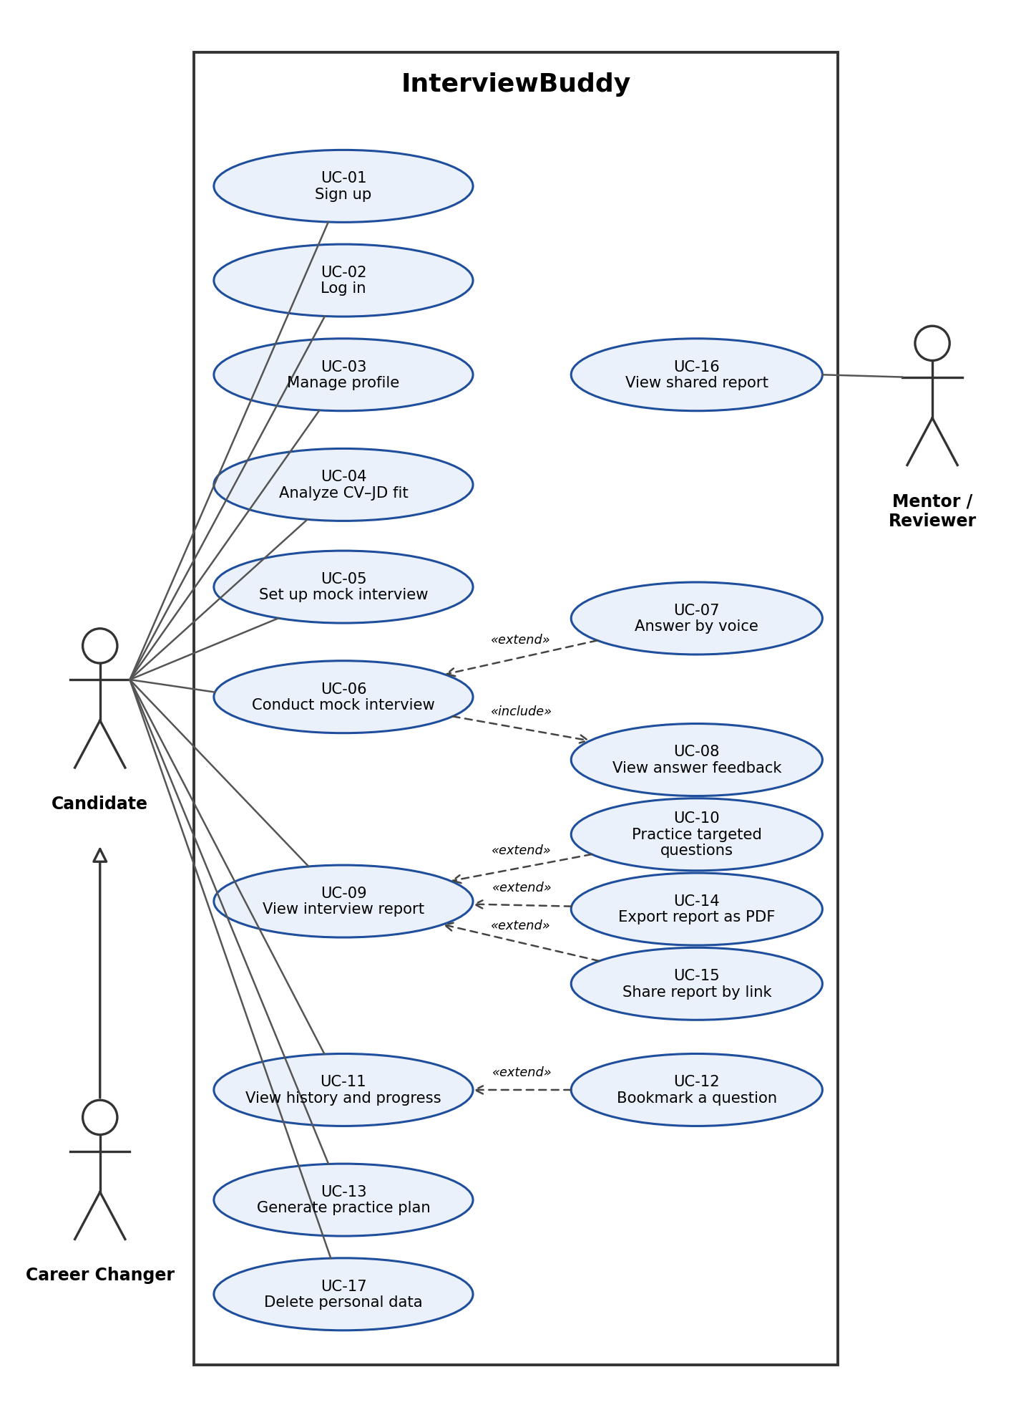
Figure 1. Use-case diagram of InterviewBuddy (from the Use-Case Specification)
Table 2 shows the architectural components that each use case relies on. The use cases that shape the architecture most are UC-04 (AI analysis with validated output), UC-05 and UC-06 (session storage and the AI interviewer), and UC-15/UC-16 (read-only access by a person without an account).
Table 2. Use cases and the components they use
ID | Use case | Main components (Section 4) | Status
UC-01, UC-02 | Sign up, Log in | Web Client, Supabase Auth, Proxy | Done
UC-03 | Manage profile | Web Client, Data (profiles) | Sprint 3
UC-04 | Analyze CV–JD fit | Web Client, API Server (/api/extract-cv, /api/analyze-fit), AI Integration, Data | Done (saving: Sprint 3)
UC-05 | Set up mock interview | Web Client, API Server (/api/interview), Data | API done; page Sprint 3
UC-06, UC-07 | Conduct interview, Answer by voice | Web Client (Web Speech API), API Server, AI Integration, Data | Sprint 3
UC-08, UC-09, UC-10 | Feedback, Report, Targeted practice | API Server, AI Integration, Data (feedbacks, reports) | Sprint 4
UC-11, UC-12 | History, Bookmark | Web Client, Data | Sprint 4–5
UC-13 | Generate practice plan | AI Integration, Data | Sprint 5
UC-14, UC-15, UC-16 | Export PDF, Share link, View shared report | Web Client, API Server (service-role read by share token) | Sprint 5
UC-17 | Delete personal data | Data (cascading deletes) | Sprint 5

Logical View
InterviewBuddy uses a three-tier architecture inside a single Next.js application. The client tier is the React pages running in the browser. The application tier is the Next.js server: the Proxy, Server Components and the API Route Handlers, which use the domain modules in lib/. The external services are Supabase (authentication and PostgreSQL) and Google (Gemini and OAuth). Only the application tier holds secret keys and calls the AI service.
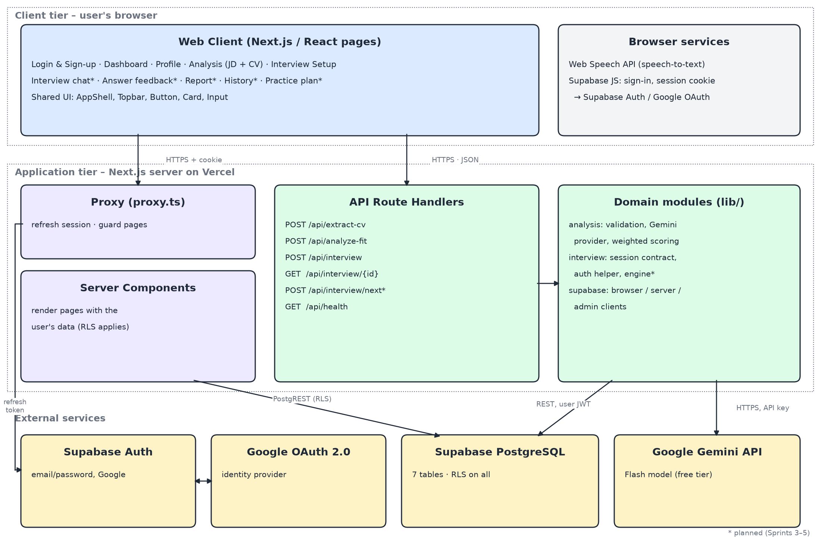
Figure 2. Logical architecture and communication between components
Table 3. Components of the logical view
Component | Responsibility | Communicates with
Web Client | Pages and forms; client-side checks; speech-to-text; shows AI results. | API Server over HTTPS (JSON, session cookie); Supabase Auth over HTTPS (sign-in).
API Server | Checks the signed-in user, validates input, applies business rules, calls the AI, reads and writes data. | Web Client (HTTPS/JSON); Supabase PostgREST with the user's JWT; Gemini over HTTPS with the server-only API key.
AI Integration | Builds prompts, calls Gemini with a JSON schema, validates and scores the output, maps errors. | Gemini API over HTTPS; used only inside the API Server.
Data and Authentication | Stores users, profiles, analyses, sessions, questions, answers, feedback and reports; enforces RLS; issues sessions. | API Server and Server Components (PostgREST, HTTPS); browser for sign-in; Google OAuth 2.0.

Component: Web Client
The Web Client contains the pages of the App Router (app/) and the React components in components/. Pages inside the (workspace) route group share the AppShell layout (sidebar and Topbar) and are protected by the Proxy, which redirects signed-out users to /login. Figure 3 shows the key classes; a React component is modelled as a class whose attributes are its props and state.
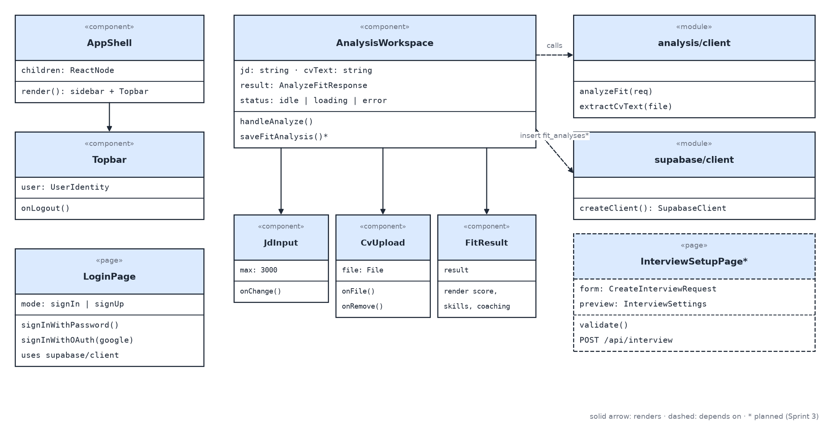
Figure 3. Class diagram of the Web Client (key classes)
- AnalysisWorkspace holds the job description, the CV text, the analysis result and the loading/error state of the Analysis page (Screen 2). It renders JdInput (3000-character limit), CvUpload (PDF upload and removal) and FitResult.
- analysis/client is the only place that calls the analysis endpoints: extractCvText() sends the PDF to /api/extract-cv and analyzeFit() sends the texts to /api/analyze-fit. It converts error responses into typed errors that the page can show.
- supabase/client creates the browser Supabase client with the public anon key. It is used for sign-in and, from Sprint 3, for saving the analysis result in fit_analyses (RLS checks the owner).
- InterviewSetupPage (planned for Sprint 3, owner Tài) builds a CreateInterviewRequest from the form, shows the preview and posts it to /api/interview. Its field names are the types published in lib/interview/session-contract.

Component: API Server
The API Server is the set of Route Handlers under app/api/ and the server-side modules they use. Every handler gets the user from the session on the server; the request body never contains a user id. Handlers use a Supabase client that acts as the signed-in user, so the database applies RLS to every query.
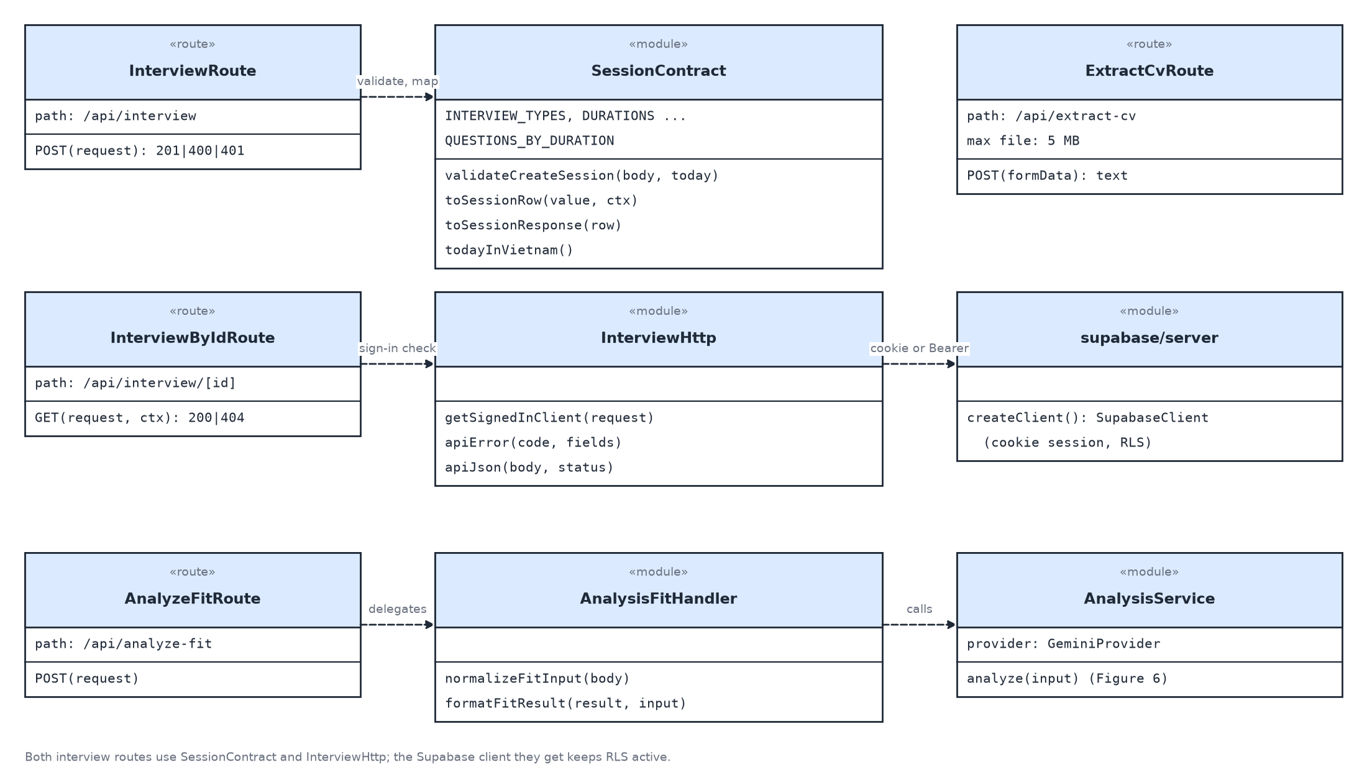
Figure 4. Class diagram of the API Server (key classes)
- InterviewRoute / InterviewByIdRoute implement POST /api/interview (create a session) and GET /api/interview/{id} (read a session with its linked analysis). Another user's session returns 404, so session ids cannot be probed.
- SessionContract validates the request (allowed values, required fields, unknown fields, interview date not in the past in Vietnam time), derives the number of questions from the duration (15 → 5, 30 → 8, 45 → 12) and maps between the camelCase API and the snake_case database columns.
- InterviewHttp returns a Supabase client for the signed-in user from the session cookie or from an Authorization: Bearer token (used by Postman and the test scripts), and builds the standard error body { error: { code, message, fields? } }.
- AnalyzeFitRoute / AnalysisFitHandler validate the CV and JD texts, call the AnalysisService and convert the result into the response used by the Analysis page.
Table 4. API endpoints
Endpoint | Purpose | Status
POST /api/extract-cv | Extract text from an uploaded PDF (max 5 MB); warn when the PDF has no text. | Done
POST /api/analyze-fit | Compare CV and JD with Gemini; return score, skills, requirements, coaching. | Done
POST /api/interview | Create a session from the setup settings; link the latest analysis. | Done
GET /api/interview/{id} | Read a session's settings and its linked analysis. | Done
GET /api/health | Check that Supabase and Gemini are reachable (no keys returned). | Done
POST /api/interview/next | Save an answer, score it and return the next question (one AI call). | Sprint 3
POST /api/interview/{id}/report | Compute criterion scores and speaking metrics; AI writes the summary. | Sprint 4

Figure 5 shows how the components work together when the Candidate creates an interview session (UC-05).
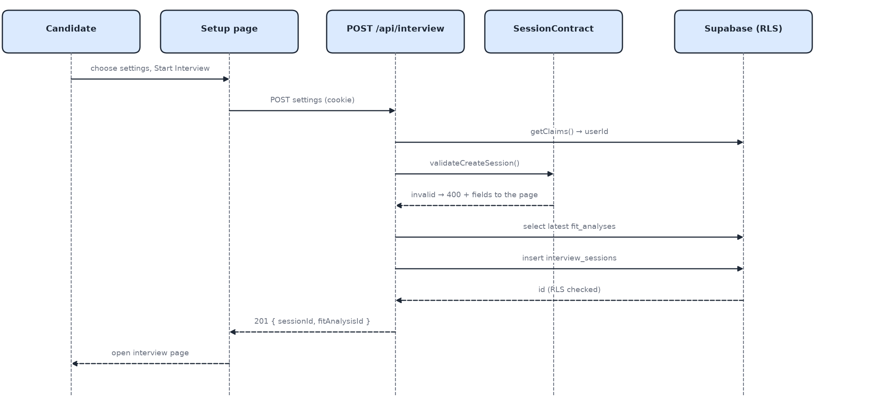
Figure 5. Sequence diagram: create an interview session (UC-05)

Component: AI Integration
The AI Integration component isolates every call to Google Gemini behind the AnalysisService, so that the model, prompts and validation rules can change without changing the routes or pages.
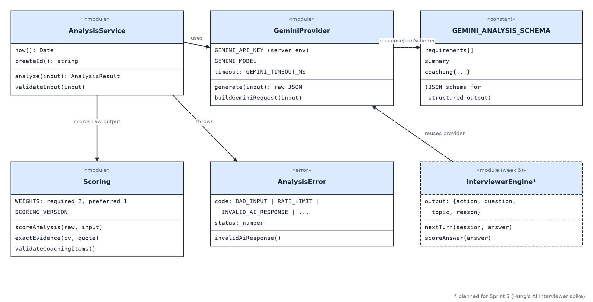
Figure 6. Class diagram of the AI Integration component
- GeminiProvider builds the request (system instructions, CV and JD as data) and calls the model named in GEMINI_MODEL with responseJsonSchema, so Gemini must answer in the agreed JSON shape. The API key and a time-out (GEMINI_TIMEOUT_MS) are read from server environment variables.
- Scoring never trusts numbers from the AI: it checks that every matched skill quotes evidence that really exists in the CV, removes duplicate skills and computes the fit score in code with fixed weights (required 2, preferred 1). Coaching advice may refer only to skills found in the requirements.
- AnalysisError maps failures to the codes used by the API (BAD_INPUT, RATE_LIMIT, INVALID_AI_RESPONSE, …) so the page can show a clear message and a Try again option (UC-04 alternative flow 5).
- InterviewerEngine (planned for Sprint 3) will reuse the provider. Its output contract is { action: follow_up | new_topic | end, question, topic, reason }, validated with a JSON schema like the analysis.

Component: Data and Authentication
Supabase provides authentication and a PostgreSQL 17 database in the ap-southeast-1 (Singapore) region. Users are stored by Supabase Auth in auth.users; a trigger creates the matching profiles row at sign-up. Figure 7 is the data view: the entity–relationship diagram of the application tables, which matches the database after the two migrations in src/supabase/migrations.
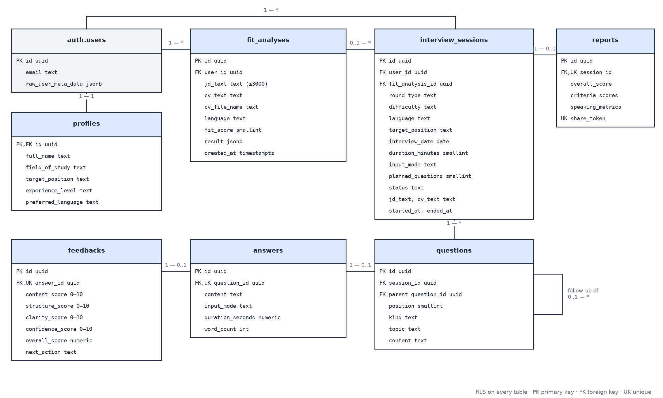
Figure 7. Data view: entity–relationship diagram
Table 5. Database tables
Table | Content | Relationships
profiles | Field of study, target position, experience level, preferred language (UC-03). | 1–1 with auth.users
fit_analyses | Saved CV–JD analysis: JD and CV text, fit score, full result (UC-04). | Many per user
interview_sessions | Setup settings, status, JD/CV snapshot (UC-05, UC-06). | Many per user; optional link to one analysis
questions | Ordered questions; follow-ups point to their parent question (UC-06, UC-10). | Many per session
answers | Typed or transcribed answer, duration and word count (UC-06, UC-07). | At most one per question
feedbacks | Four rubric scores 0–10, explanation, sample answer, AI's next action (UC-08). | At most one per answer
reports | Scores by criterion, speaking metrics, summary, share token (UC-09, UC-15). | At most one per session

Security rules. RLS is enabled on every table. Users can read and change only rows they own, directly through user_id or through the session the row belongs to. A session can be linked only to the user's own analysis; this is checked by the database, because a foreign key alone does not check ownership. Shared reports (UC-16) are not readable through RLS: a server route looks them up by their unguessable share token with the service-role key, which is used only on the server. Deleting a user deletes all of their data (UC-17).
Authentication flow. Email/password sign-in and Google sign-in (OAuth 2.0) are handled by Supabase Auth. After a Google sign-in or an email confirmation, Supabase redirects to /auth/callback, which exchanges the one-time code for a session cookie. The Proxy refreshes this cookie on every request, and the server always identifies the user with getClaims(), which verifies the token.

Deployment
Figure 8 maps the components of Section 4 to the machines and cloud services that run them.
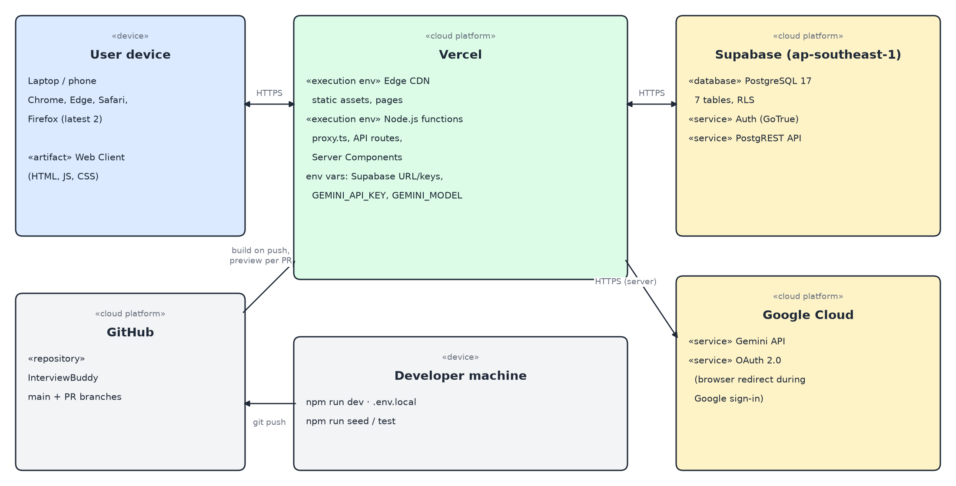
Figure 8. Deployment diagram
Table 6. Deployment nodes
Node | Runs | Notes
User device (browser) | Web Client: HTML, JavaScript and CSS; Web Speech API. | Chrome/Edge recommended for voice; typing works everywhere.
Vercel | Static pages and assets on the edge network; Proxy, Server Components and API Route Handlers as Node.js functions. | Secret keys are set as environment variables in the Vercel dashboard, never in Git.
Supabase (ap-southeast-1) | PostgreSQL 17 with RLS, Supabase Auth, PostgREST API. | Schema created only from migration files.
Google Cloud | Gemini API (called only by the API Server); OAuth 2.0 for Google sign-in. | Free-tier quota; model name in GEMINI_MODEL.
GitHub | Source code repository (main branch and one branch per task). | Each pull request gets a Vercel preview link; main is the staging site.

Environments. Each developer runs the application locally (npm run dev) with their own .env.local. Every pull request is deployed by Vercel to a preview URL, and the main branch is deployed as the staging site used for testing and for the PA submissions. All environments currently share one Supabase project; test data is created by npm run seed for two dedicated test users only.
Recommendation. The Vercel functions should run in a region close to the Supabase database in Singapore, because every API request makes one or more database calls. This keeps database latency low and helps meet the 3-second and 5-second performance targets.

Implementation View
The repository follows the folder structure required by the course. All application code is in /src; the component folders are:
InterviewBuddy/
├── src/
│ ├── app/ Web Client pages and API Server routes
│ │ ├── (workspace)/ protected pages: dashboard, analysis, interview, ...
│ │ ├── login/ sign-in and sign-up page
│ │ ├── auth/callback/ Supabase redirect after Google sign-in
│ │ └── api/ API Server: analyze-fit, extract-cv, interview, health
│ ├── components/ Web Client components
│ │ ├── ui/ shared Button, Card, Input
│ │ ├── layout/ auth/ dashboard/ analysis/
│ ├── lib/
│ │ ├── analysis/ AI Integration: Gemini provider, schema, scoring
│ │ ├── interview/ session contract, auth helper (engine in Sprint 3)
│ │ └── supabase/ browser, server, admin and proxy clients
│ ├── supabase/migrations/ Data: SQL migrations (schema and RLS)
│ ├── scripts/ seed data, end-to-end and verification scripts
│ ├── tests/ unit tests (npm test)
│ ├── proxy.ts Proxy: session refresh and page protection
│ └── .env.example names of the environment variables (no values)
├── docs/ (management, requirements, analysis and design, test, api)
└── pa/ (one folder per assignment)
Table 7. Mapping of components to source folders
Component | Folders | Owner
Web Client | src/app (pages), src/components | Tài (layout, login, setup, profile); Khang (analysis)
API Server | src/app/api, src/lib/interview | Nhân (session API); Khang (extract-cv); Hưng (analyze-fit)
AI Integration | src/lib/analysis (interviewer engine from Sprint 3) | Hưng
Data and Authentication | src/supabase/migrations, src/lib/supabase, src/proxy.ts | Nhân

Changes reach main only through reviewed pull requests. Database changes are new migration files; API contracts are updated in /docs/api before the code changes, and consumers are told on Slack.

